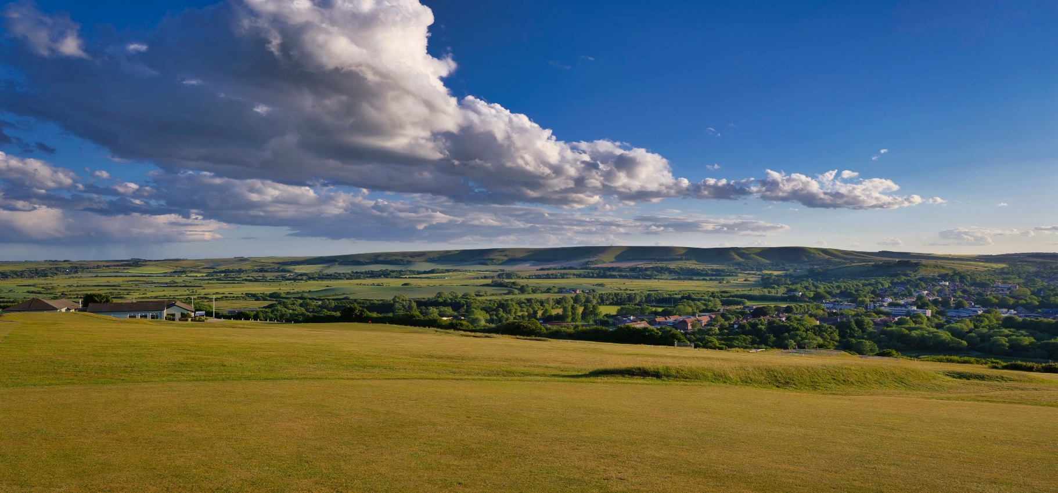
Lewes Golf Club
Ladies Open
Monday 9th September 2024

NEW FORMAT! NEW DATE!
18 Hole Stableford Competition. Teams of 4, 2 scores to count per hole, 85%.
Maximum Handicap Index 36
Entry Fee: £160 per team
To include Coffee & Biscuits, 2 Course Buffet Lunch, Halfway House & Prizes.
CDH Number required. All entrants must have a Club acquired Handicap Index.
Lewes Golf Club – Ladies Open- Monday 9th September 2024
Player 1
Forename………………………………………Surname……………….……………………………Hcp Index…...………….….
Email…………………………………………………………………………………….Telephone……………………………………….
Club……………………………………………………………………………….CDH No……………………………….………………….
Player 2
Forename………………………………………Surname……………….…………………………..Hcp Index…...………….…..
Club……………………………………………………………………………….CDH No……………………………….………………….
Player 3
Forename……………………………………..Surname……………….…………………………….Hcp Index.....………….….
Club……………………………………………………………………………….CDH No……………………………….…………………
Player 4
Forename…………………………………….Surname……………….…………………………….Hcp Index…...………….….
Club……………………………………………………………………………….CDH No……………………………….…………………

Entry Fee £160.
Please send applications to Lewes Golf Club, Chapel Hill, Lewes, BN7 2BB. Tel: 01273 483474
Internet Banking: Sort Code 40 28 15, Account No. 23663191, Lewes Golf Club Ltd
Please give lead name as reference plus ‘LO’
Cheques may be made payable to Lewes Golf Club Ltd.

